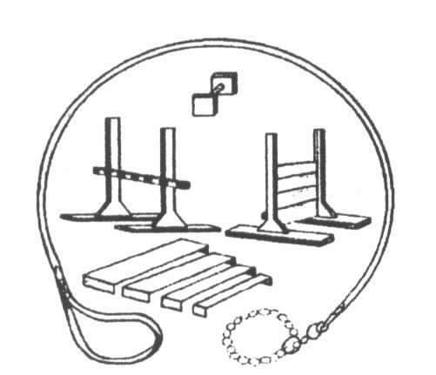
Youngstown
All-Breed Training Club presents:

Intro to Conformation Class and Run – Thrus

January 11, 2026 through February 15, 2026

Our Beginner’s Class is a 6 week course with your dog on Sundays from 1:00pm - 2:30pm weekly. Cost is $120.00 per person and this includes your one entry to the match.
(Discount for YABTC members)

This class will go through everything from the basics, such
as grooming tips/filling out entry forms etc., to actual ring time working on moving and stacking.

As the situation is continually being monitored for safe classes / certain protocols may be required.

Registration is a MUST !! // (Space is extremely limited so call NOW!!)

Come and join us at the Youngstown All-Breed Training Club –
13210 Mahoning Avenue s P.O. Box 397 s North Jackson, Ohio s 44451
(New Location - West of Bailey Road, Across from the North Jackson water tower.)

Register now by calling: 330-538-3903 – Leave message for Susan (answering machine is for Fithian Travel) or by email: Cherokee538@att.net
(Please include: Confo class in the subject line)

