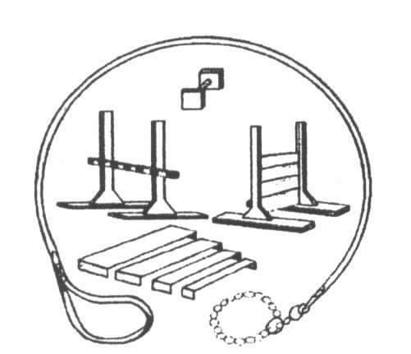
Youngstown
All-Breed Training Club presents:

Intro to Conformation Class and Run – Thrus

January 13, 2013 through February 17, 2013

Our Beginner’s Class is a 6 week course with your dog from 1:00pm - 2:00pm weekly, culminating with the finale at the puppy match held at YABTC on Sunday, March 3, 2013. Cost is $60.00 per person (includes one entry to the puppy match).

Registration is a MUST !!
(Space is limited so call NOW!!)

All-Breed Conformation Run-Thrus will be held weekly through February in conjunction with the Beginner’s class from 2:00pm – 3:00pm / Cost is $5.00 per handler.

Come and join us at the Youngstown All-Breed Training Club –
11801 Mahoning Avenue s P.O. Box 397 s North Jackson, Ohio s 44451
Conveniently located just southeast of the Route 80/Bailey Road exit or west of the 76/80 Turnpike exit
Across from Carter Lumber
Register now by calling: 330-538-3903 – Leave message for Susan Fithian or by email: Cherokee538@att.net (include: Confo class in the subject line)

